**Book-A-Study Room**

**Deliverable #1**

September 7th, 2018

**HAXORS**

Eliza Gaudio (1554032)

Elie Sader (6128748)

Jonnie Klein Quezada (1640380)

Kevin Hirsh (1634710)

Kyle Nancoo (1441915)

**Client organization:**

Vanier College Library

**Client name:**

Haritos Kavallos

**Table of Contents**

Executive Overview…………………………………………. 3

Project development based on previous knowledge…....... 4

Client/sponsor and potential user(s) description…...... 4-5

Computer skills and literacy for client/user(s)…………….. 5

Meetings………………………………………………………........ 6

Sample Agenda……………………………………………………. 6

Online Repositories.……………………………………………… 7

Communications………………………………………………….. 7

Work…………………………………………………………………. 7

Areas of Responsibility………………………………………. 7-8

Contact Information…………………………………………...... 8

Gantt Chart……………………………………………………...... 9

**Executive Overview**

To give a brief summary, our prototype is going to be built for the Vanier College library, and it’s basically going to be a system where students will have the privilege of booking a study room for an allocated period of time.

The study rooms are only allowed to be booked for a maximum block of 3 hours during a day, and no less than 3 people can book a room. For example, if a student wants to book a room solo, they would not be able to, as they would be compromising space for the people who really need it. Students will also be prohibited from booking more than one room at a time, and will have to somehow check-in once they are ready to use their room, that way if they don’t show up, the other students won’t miss out on the chance to book a study area.

This report talks about several pointers. First and foremost, we mention the languages we intend on using in this project, such as React.js and SASS for styling, knowledge from Internet I and II on HTML and CSS, as well as Database I course knowledge to build the actual database of this prototype, using MySQL or Oracle, and learning new languages like Node.js, Passport.js, and etc.

We talk about our client, what organization he takes part in, and what job he does for this particular organization. Our client’s name is Haritos, and he works as the administrator for the Vanier library. We are currently building him the prototype booking system database, and he will be dealing with us hands-on to get this project in motion.

We also mention the particular skills needed from our client and users to make this prototype have reasonable data, and be properly tested. Each user, and our client, need to have basic knowledge of Omnivox, and its functions, and must be able to use technology in the most straightforward way.

This report also includes information about our project plan, uses a Gantt chart to indicate how we will be splitting our work, and who will be doing what. We have estimated our project to take anywhere between 13-14 weeks to complete, with time to learn the languages on our own, and also start implementing the data to build the prototype.

**Project development based on previous knowledge**

Being in the 4th semester of this program, we’ve learnt quite a lot of material to get us ahead in this career field. For this project, we will be combining a sequence of knowledge we have already gained from previous semester courses, such as Internet I and II, in addition to Database I. We will also be implementing new knowledge by self-teaching ourselves new languages, for the purpose of this project, as well as to benefit us for the future, and get ourselves ahead.

For the sake of new learning, we will be taking the time to learn languages like React.js and SASS. This will be for the purpose of design, which highlights the front-end of our prototype. The reason behind using these languages is because of their aesthetic. They’re simple to use, and their outcome is visually pleasing. For the back-end, we will be learning Node.js, Express – Node.js and Passport.js. These languages are also fairly practical to use.

In our Internet I and II courses, we learnt a lot about how to build basic websites, with the use of HTML, CSS, JavaScript, PHP, etc. For this project, we intend on using the knowledge we’ve gained on HTML and CSS to design a clean, easy-to-use interface for the website that’s going to make up our booking system prototype. Incorporating the new languages with the mixture of our current knowledge will set up a strong design.

In Database I, we got an introduction to databases and how they function/what they do. We learnt how to create them and what the different types of databases are. In order to implement this project, we will be using databases, and we’ll be doing that by using the knowledge we gained from that course. In Database I, we worked with Oracle, and for this project, we intend on doing the same thing, with the possibility of also using MySQL. This will create a simple way for users to input their data, and for us as the implementers to retrieve it.

**Client/sponsor and potential user(s) description**

Our client for this project can be found at Vanier College, in the library department. To describe our client himself, his name is Haritos Kavallos, and he is the coordinator of the library. He is part of the administration, he takes care of any issues happening in the library, and manages what goes on in the department itself.

Describing the organization itself is fairly simple; the library is a department in the actual college. The college has a three floor library that has study rooms, tons of books to rent out/research information with, and they also have quiet areas where you can do homework. The library deals with anything that has to do with student academics. Our prototype is to create a website where students can book one of the quiet study rooms that are in the library, and for a certain allocated period of time, where no less than 2 students can book a room, and a study room cannot be double-booked. In addition to that, we’ll only allow students to book a room for a specific amount of time, that way they won’t be able to book a room for the entire day, leaving the chance for other groups to use the rooms as well.

To describe the users, it will consist of the students who are enrolled at the college. To test this prototype, we’ll gather a small group of students who are willing to try it out, and we’ll build from there. Each student is going to be different, some being in our program, and others being in different programs across the college who will need to book a study room to do their work/study for their exams.

**Computer skills and literacy for client/user(s)**

In order to use our prototype, you just have to know how to use a technological device. The prototype is going to be designed in such a way that it’ll be easy to use, and easy to understand.

The students who are going to be using our website will need to have basic knowledge on how to use Omnivox, which is pretty much a given, since all students must know how use it to access their student documents and student file. Moreover, they’ll be able to access the booking system website through their portable device, as well as on a desktop. For that, they’ll need to be able to navigate through the Omnivox app, and/or the Vanier College website. However, students do not need to necessarily be tech savvy to use this. The quality and level of skill will differ from one student to another, but no student should run in to any issues using the website, as it will be easily accessible.

As for our client, he will as well need to have basic knowledge on how the Omnivox system works, and how to navigate through our website. Haritos has a pretty big understanding on how technology works, and he’s pretty experienced, as he has also previously studied in Computer Science.

**Meetings**

Our group meetings are an hour long each at the computer science lab, being held on Mondays from 8:30 am to 9:30 am and an optional meeting from 2:30pm to 3:30pm and Thursdays from 10:00 am to 11:00 am. The optional meetings are considered optional as they allow our team to get together to work on tasks which require collaboration, but we may not all have to be there for certain tasks. As for our client meetings, it is being held at his office and we will be meeting with our client once every two weeks which will replace our optional meeting on Mondays from 2:30pm to 3:30pm to discuss and ask questions about our project.

**Sample Agenda**

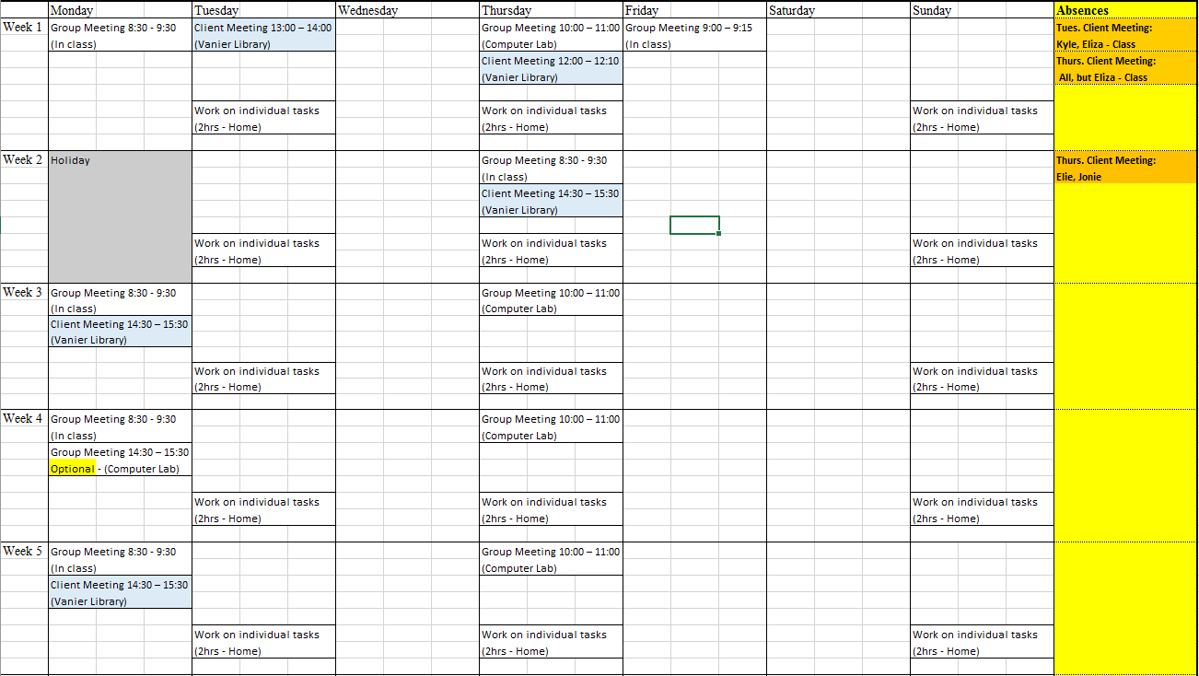

**Online Repositories**

Currently the Online repository that we are using is GitHub to store and share all files between all team members. We have setup separate branches for each member to facilitate pull requests and minimize clutter.

**Communications**

Regarding communication, our team is communicating through an application called discord for little discussions and questions that can be answered quickly, but when we need to discuss of something major, it is to be done in person with all team members present. We also use discord to remind members about certain deadlines and important dates. Finally, we have a bot within the server which is linked to our GitHub repository and notifies members whenever there is a change to the repository.

**Work**

Work that is to be done for all team members can be done at home or the lab, but team members are to fulfill 4-6 hours a week, on average, depending on if we are ahead of schedule or behind. If there is work that is needed for all team members to be present, then the work will be done in the lab or during optional meetings. Generally, the work that will be done at home will be the programming of the fully designed databases and website, as well as the self-teaching of the required languages to complete the project.

**Areas of Responsibility**

We have decided to have the team leader of each deliverable be the one responsible for communicating with the client and making sure the reports are formatted and delivered on time. This makes it less confusing for the members overall as they do not need to keep track of which member is on rotation for being the client contact and being the manager for the reports.

**Primary Client Contact**

**Deliverable 2** ----------------- Jonnie Klein Quezada

**Deliverable 3** ----------------- Eliza Gaudio

**Deliverable 4** ----------------- Kyle Nancoo

**Deliverable 5** ----------------- Elie Sader

**Deliverable 6** ----------------- Kevin Hirsh

**Deliverable 7** ----------------- Jonnie Klein Quezada

**Report Manager**

**Deliverable 1** ----------------- Kevin Hirsh

**Deliverable 2** ----------------- Jonnie Klein Quezada

**Deliverable 3** ----------------- Eliza Gaudio

**Deliverable 4** ----------------- Kyle Nancoo

**Deliverable 5** ----------------- Elie Sader

**Deliverable 6** ----------------- Kevin Hirsh

**Deliverable 7** ----------------- Jonnie Klein Quezada

**Contact Information**

Kyle Nancoo **Email**: kylenancoo3@gmail.com **Tel**.: (514) 661-2820

Eliza Gaudio **Email**: eliza_gaudio@hotmail.com **Tel**.: (514) 557-2828

Elie Sader **Email**: sader_elite@hotmail.com **Tel**.:(514) 585-6215

Jonnie Klein Quezada **Email**: jonniequezada@gmail.com **Tel**.: (514) 946-9008

Kevin Hirsh **Email**: khirsh98@gmail.com **Tel**.: (514) 836-5525